17.36: a) The work done by friction is the loss of mechanical energy,

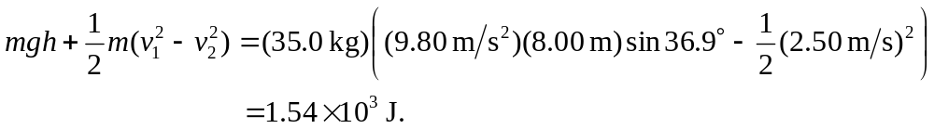

b) Using the result of part (a) for Q in Eq. (17.13) gives

